Chapter 6

Optimum design

Optimum design

6.1 Green Energy Technologies Compact Wind Turbine

Green Energy Technologies uses a shroud to create a “wind tunnel” effect to capture and amplify wind, optimized rotors to maximize the energy captured, and automated yaw control to keep the rotors pointed into the wind, which enables their WindCube to generate more energy in less space than standard free stream wind turbines.

Two Wind Cube can be stacked, doubling the grid compatible power generated. Its compact size also makes it ideal for urban rooftops, industrial plants, and integration into new construction

6.2 Advantages of the WindCube

- Can be installed and operational quickly
- Scalability (install one now and others later)
- Easier to maintain than large wind turbines (all components easily accessible)
- Unique design increases power generation
- Smaller footprint
- No land needed

6.3 Fundamentals of the Technology

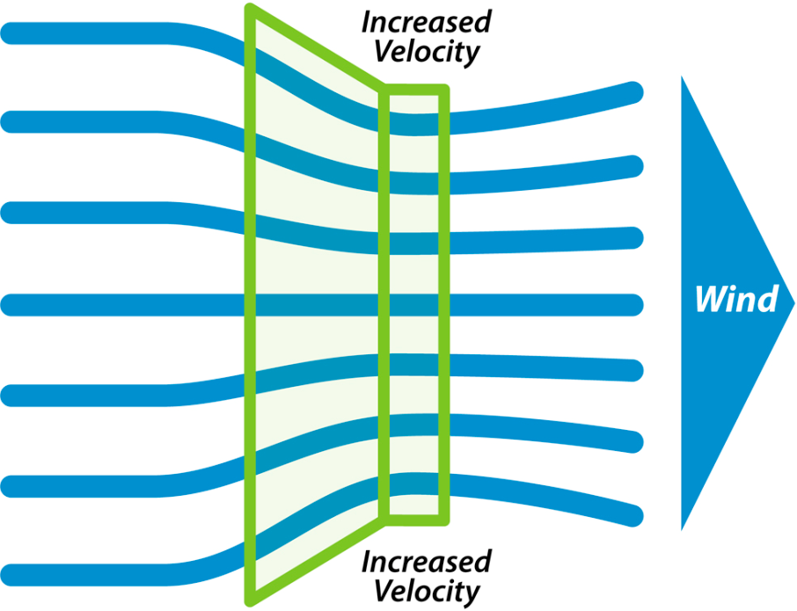
- Power output increases rapidly with increase in wind velocity at the blades.
- P = 0.5 (air density) (area) (air velocity)3
While the rest of the wind industry generates energy using freestream wind, WindCube's shroud captures and amplifies wind to produces more electricity.

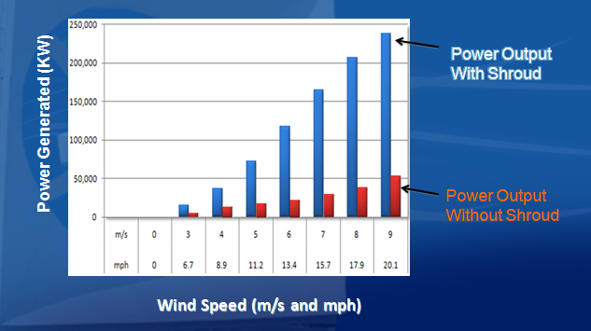

WindCube Components6.4

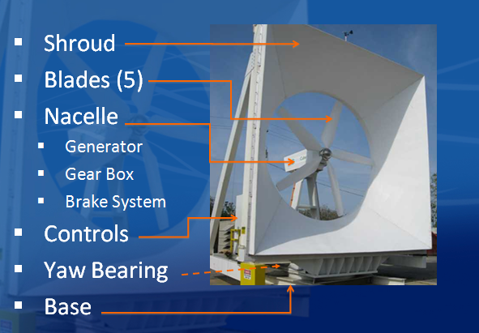

6.5 How it works:
As the wind blows, the Wind Cube orients itself into the wind via an electromechanical yaw system. The shroud then catches the wind, forcing it through the turbine. The turbine generator is connected directly to your business and as electricity is generated- your business is powered. If the wind isn't blowing your business is powered by the energy grid as usual. If the wind is blowing strongly then your energy produced can exceed your energy consumed and, depending on your local utility, your meter can spin backwards rolling back your energy bill. The Wind Cube can operate at ambient wind speeds which helps keep a constant flow of power into the system.

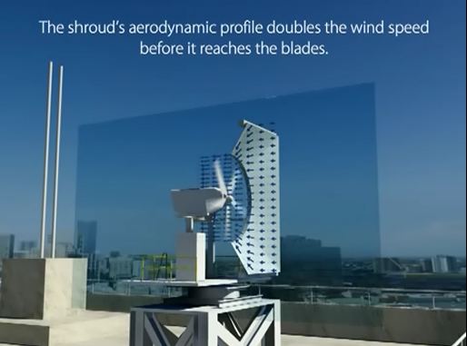

The patented shroud technology optimally funnels the wind toward the rotor. The aerodynamic profile will double the wind speeds before reaching the blades making the Wind Cube capable of producing 8 times as much energy. The airfoil design is optimized to take full advantage of the shroud and produce the maximum amount of kilowatt-hours (kWh).

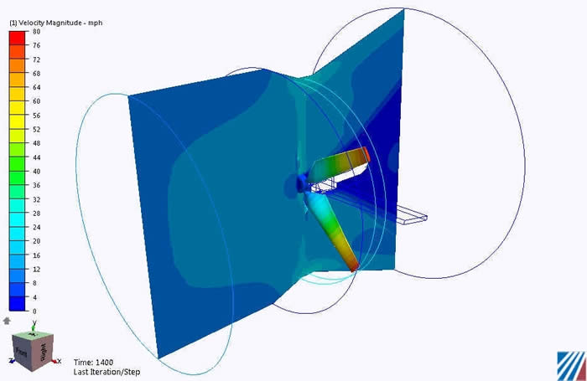

The rotor blades on the Wind Cube are designed for maximum lift, efficiency and structural integrity.

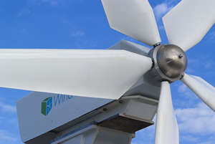

The aircraft-style braking system has two internal brakes for high winds and maintenance

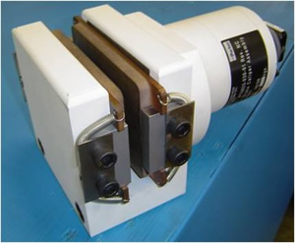

The yaw system moves the Wind Cube into prevailing winds taking full advantage of your wind resource via our on board PLC and customized software. At high wind speeds, the yaw system moves the Wind Cube away from the prevailing winds and enables the braking system. The uniquely designed bearing requires minimum lubrication and predictive maintenance.

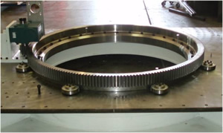

Safety is always the first priority. The WindCube features easy access maintenance ladders and platforms. This is especially important for WindCubes mounted on tall urban roofs.
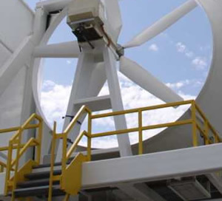

Wind power is the fastest growing industry in the alternative energy sector. Wind turbines generate clean and green power for us but they have certain precondition. One of it is the power unit has to be set up in strong wind area. But green energy Technologies has developed a brand new wind power generator known as the Wind Cube. It is smaller compared to the normal wind generator.

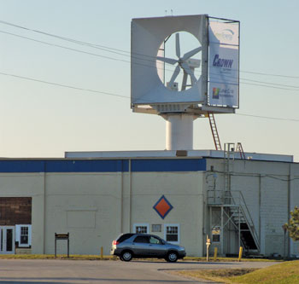

6.6 American Wind cube overview:

The Wind Cube relies on its "wind tunnel" effect known in physics as the Bernoulli Principle. While the rest of the wind industry generates energy through the use of free-stream wind, the Wind Cube captures and amplifies the wind, which produces more kilowatt-hours (kWh). As wind encounters the Wind Cube shroud, it becomes concentrated creating increased velocity and in turn, more power. By amplifying the natural wind speed, the Wind Cube is able to produce more power from a smaller footprint. Proportionally, the Wind Cube has the smallest footprint with the largest amount of power output in the industry. Because of these attributes, the Wind Cube is uniquely designed to produce energy in urban, populated areas with space constraints.
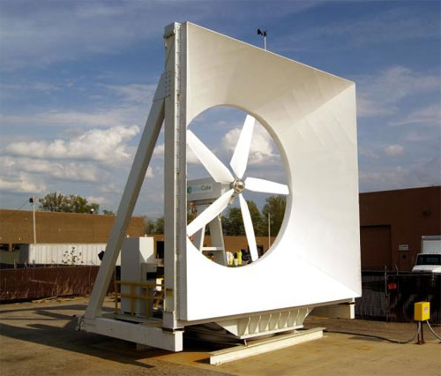
With the Wind Cube, building owners everywhere can now consider being a part of the renewable energy picture."
6.7 Applications:

Through on-site generation and net metering, the Wind Cube allows customers to immediately offset all or part of their electric usage and take advantage of wind energy as a viable source of power. The Wind Cube's groundbreaking design allows large power-users to integrate wind energy generation into a variety of standard urban roofs. If roof space is limited or incompatible, the Wind Cube may be tower-mounted. Because of the Wind Cube's superior flexibility, a wide-range of users, including industrial facilities, retail centers, commercial office buildings, schools, resorts and electric users in remote corners of the world can now benefit from wind energy.
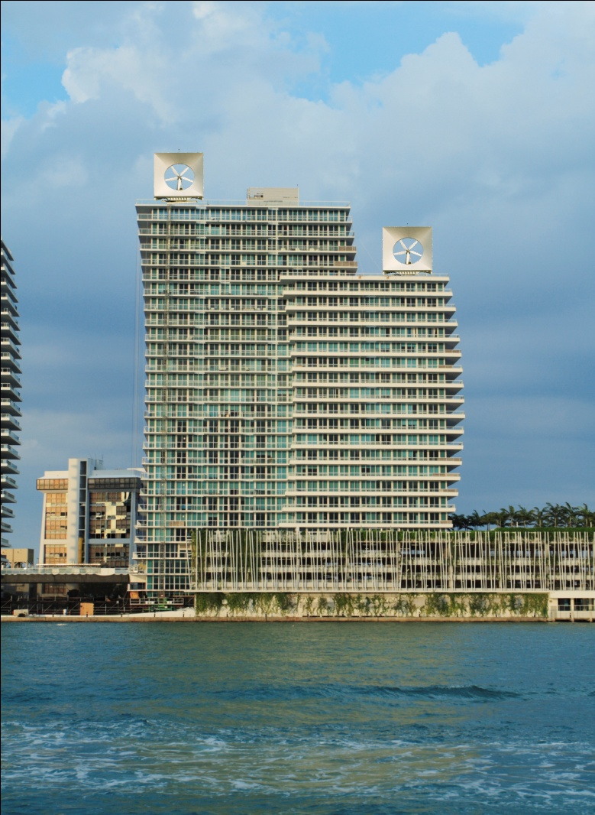

Wind cube already assembled above the roof of a building.

Building owners anywhere can consider being a part of the renewable energy picture. With Wind Cube, it’s not necessary to have the wind of low wind cities to become a generator of wind power. In cities with excellent renewable energy incentives, moderate wind and high electric rates, the payback can be as little as three years.
When we go for a new product we look for the ease of application and scalability. Wind Cube satisfies both of these criteria and presents one of the first viable opportunities for commercial distribution of wind-power generation facilities to residential markets and businesses as well.

6.8 American wind cube design:

Measuring a mere 22 x 22 x 12 feet, the commercial wind turbines are intended to fulfill a vast array of consumer’s energy needs; from industrial office buildings, to large-scale retailers, utility customers in isolated areas, and even university campuses.
6.9 Our wind cube design:

The up-frame:

The inlet frame is a square 2m×2m and the thickness of the corner is 4 cm and the outlet frame is a circle with radius 0.5 m and thickness of 4 cm attached with tunnel with length 0.4m and radius of 0.5 m
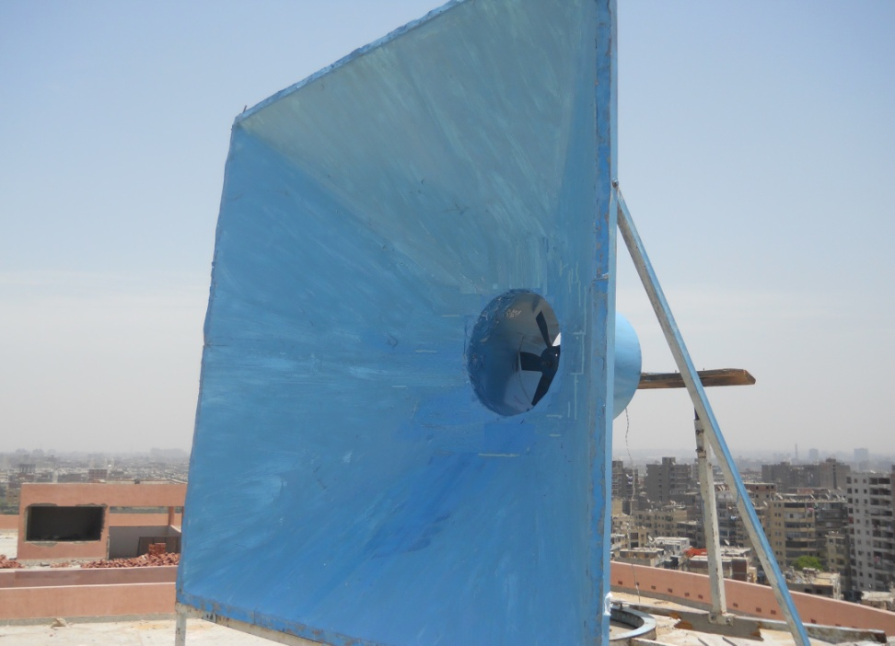

The rotor blades made of thin steel selected to have the best efficiency rather than the other blades we tried to test that made of PVC.
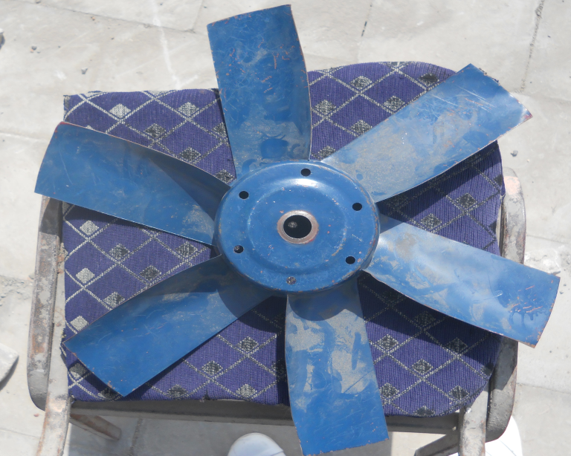
The yaw system we made was manually moving the Wind Cube into the direction of wind, The outer frame of the base which is 1.5m × 2 m connects to a ring of diameter 84 cm with 6 supports by welding , inside this ring there is a collar of diameter 83 cm which is fixed with the base body with 8 bolts 8mm , and between them there is a grease , above them there is another ring which is fixed with the collar with the bolts.

